**THE CHATBOT**

A Mini Project Report submitted to Savitribai Phule Pune University, Pune



In partial Fulfillment for the awards of Degree of Engineering in Computer Engineering

**Submitted by**

**Mr. Deshmukh Sahil Sachin Exam Seat No.**

**Ms. Gaikwad Akshada Vasant Exam Seat No.**

**Under the Guidance of**

# Dr. K. M. Sanghavi



**May 2022-23**

**Department of Computer Engineering**

SNJB’s Late Sau. Kantabai Bhavarlalji Jain, College of Engineering, Chandwad Dist.Nashik

SNJB’s Late Sau. Kantabai Bhavarlalji Jain , College of Engineering, Chandwad, Dist. Nashik

Department of Computer Engineering

(2022-23)

Certificate



This is to certify that,

Deshmukh Sahil Sachin,

Gaikwad Akshada Vasant,

Have successfully completed the Mini project entitled “ **The Chatbot** ”under my guidance in partial fulfillment of the requirements for the Third Year of Engineering in Computer Engineering under the Savitribai Phule Pune University during the academic year 2022-2023.

**Date : ……………….**

**Place:……Chandwad………….**

Dr. K. M. Sanghavi

Project Guide,

Head,

Department of Computer Engineering

## Acknowledgements

With deep sense of gratitude we would like to thank all the people who have lit our path with their kind guidance. We are very grateful to these intellectuals who did their best to help during our project work.

It is our proud privilege to express a deep sense of gratitude to **Prof. Dr.R. G. Tathed,** Principal of SNJB’s LS KBJ COE, Chandwad, for his comments and kind permission to complete this project. We remain indebted to **Dr.K.M.Sanghavi,** H.O.D.Computer Engineering Department for hes timely suggestion and valuable guidance.

The special gratitude goes to **Dr.K.M.Sanghavi** excellent and precious guidance in completion of this work .We thanks to all the colleagues for their appreciable help for our working project. With various industry owners or lab technicians to help, it has been our endeavor throughout our work to cover the entire project work.

We are also thankful to our parents who provided their wishful support for our project completion successfully .And lastly we thank our all friends and the people who are directly or indirectly related to our project work.

(Project members name)

Mr. Deshmukh Sahil

Mr. Jain Nishant

Ms. Gaikwad Akshada

Ms. Bhansali Gunjan

Ms. Avhad Ankita

***Abstract***

The "Chatbot for Students" project seeks to create a chatbot powered by AI that can help students with their academic endeavours. The chatbot will be created to respond to frequent inquiries about academic subjects, offer study resources, and make individualised suggestions based on the student's interests and learning style. The project will make use of machine learning (ML) and natural language processing (NLP) techniques to help the chatbot comprehend and reply to student inquiries. The project's objective is to produce a useful tool that will aid students in enhancing their academic performance and achieving their learning objectives.

# Table of Contents

**Acknowledgement**

**Abstract**

**Table of Contents**

1. **Introduction** 
   1. Overview
   2. Aim/Motivation
   3. Objective
   4. Organization of Report
2. **Literature Survey**
3. **Problem Statement**
4. **Software Requirements Specification** 
   1. Hardware Requirements
   2. Software Requirements
5. **System Design** 
   1. Project Block Diagram
   2. GUI of Working System
6. **Conclusion and Future Scope**

**7.References**

**Chapter 1**

## Introduction

### 1.1 Overview 1.2 Aim/Motivation 1.3 Objective 1.4 Organization of Report

**1.1 Overview** *Students will be able to access the chatbot from any device because it will be connected with the college's website and mobile application. It will include a number of functions, such as telling you when exams are, when they are, and what due dates are for assignments. Additionally, the chatbot will assist students in locating pertinent study materials, respond to academic queries, and propose extracurricular activities.*

*The Student Chatbot project's overall goal is to give students a useful tool for quick and effective information access. The chatbot will improve their educational experience and let students concentrate on their academics and accomplish their academic objectives..*

**1.2 Aim/Motivation** *As we have seen, our teachers' blogs are accessible to students and other teachers alike without the use of a chatbot on their blog websites.We are having problems locating the specific information on the relevant blog as a result.*

*A chatbot can enhance our experience of a teacher blog by offering a more engaging and tailored one.*

*By automating processes like presenting pupils with tools and materials, chatbots can save teachers time.*

### 1.3 Objectives

Project objectives are the particular goals that the project strives to meet within a given time frame.

The issue listed in the Problem Statement should be directly addressed.

* Chatbots is created to assist students in working together on projects and tasks, offering direction and assistance all along the way.

* Lessen the strain for teachers: Chatbots can let teachers focus on other crucial parts of education by automating time-consuming chores and offering support to pupils.

* Share knowledge and information: The main goal of a blog website for teachers is to share knowledge and information with their students . Teachers can utilise their blogs to communicate with their readers about their experiences, thoughts, teaching strategies, and other pertinent information.

* Supply resources: Teachers may use their blogs to give their readers resources like lesson plans, worksheets, and other learning tools. This can save its readers time and offer important support.

* Thus we have created the chatbot for teachers blog website for assisting teachers resources to students by an easy access.

* This project is based on resources such as PYTHON, JAVASCRIPT,CSS-HTML ,JSON and python libraries like NUMPY , JSONIFY , TORCH , FLASK.

### 1.4 Organization of Report

The rest of this report is organized in following manner. In all chapters, related contents are described in detail.

* **Introduction (**Chapter 1**)**:
* **Literature Survey (**Chapter 2**)**:
* **Problem Statement(**Chapter 3**)**:
* **Software Requirements(**Chapter 4**)**:
* **System Design(**Chapter 5**)**:
* **Conclusion and Future Scope(**Chapter 6**)**:
* **Reference(**Chapter 7**)**:

**Chapter 2**

## Literature Survey

O. T. et al. (2021)[1]: This study aimed to design and develop a chatbotbased learning environment for computer science students. The study found that the chatbot was effective in improving student engagement, motivation, and learning outcomes.

"Chatbot-Assisted Learning: The Effect of Conversational Agents on Learning Outcomes" by Xue, Y. et al. (2020): This study investigated the effect of chatbots on learning outcomes. The results showed that the chatbot improved students' learning outcomes, engagement, and satisfaction.

"A Systematic Review of Chatbot Technology in Education" by Liao, C. et al. (2020): This review examined the current state of chatbot technology in education. The review found that chatbots were effective in improving learning outcomes, reducing workload for educators, and enhancing student engagement.

"Integrating Chatbots in Educational Applications: A Review of Recent Advances" by Koseoglu, M. A. et al. (2019): This study reviewed recent advances in the integration of chatbots in educational applications. The study found that chatbots were effective in improving student engagement, reducing workload for educators, and enhancing personalized learning.

**Chapter 3**

## Problem Statement

* The problem statement for the Chatbot for Teachers Blog Helping Student project is that students often struggle to access relevant and timely information related to their academic needs. This can lead to frustration, confusion, and a lack of engagement in the learning process. While there are various sources of information available, such as textbooks, online resources, and teacher lectures, students often find it challenging to navigate these sources and find the information they need.

* Additionally, many teachers create blogs to provide students with additional resources and information related to their courses. However, these blogs can be overwhelming, and students may find it challenging to locate the information they need. Furthermore, students may not always have access to their teachers to clarify doubts or seek guidance.

* To address these issues, the Chatbot for Teachers Blog Helping Student project aims to develop an intelligent and interactive chatbot that can assist students in accessing relevant information from their teachers' blogs. The chatbot will be designed to understand students' queries and provide personalized responses based on the information available on the teachers' blogs.

* The goal of the project is to enhance students' learning experience by providing them with an efficient and personalized tool that can assist them in accessing information related to their academic needs. The chatbot will serve as a virtual assistant, providing students with the necessary guidance and support to help them succeed in their courses. Overall, the Chatbot for Teachers Blog Helping Student project aims to address the challenges students face in accessing relevant and timely information and provide them with a convenient and efficient solution.

**Chapter 4**

## Software Requirements Specification

**Software Used are:**

**CSS**

CSS (Cascading Style Sheets) is a language used for describing the presentation of web pages.

### JS

JavaScript (JS) is a high-level programming language that is primarily used for creating dynamic and interactive web pages.

### HTML

HTML (Hypertext Markup Language) is a markup language used for creating web pages and web applications.

### Python

Python is a high-level, interpreted programming language known for its simplicity, readability, and versatility.

### NTLK PY LIBLARY

LTK (Natural Language Toolkit) is a Python library that is used for natural language processing (NLP). It provides a wide range of tools and algorithms for working .

### Flask and Torch

Flask and PyTorch are two popular Python libraries used in different areas of software development.

### VENV (Virtual Python Environments)

The venv module facilitates the development of small "virtual environments," each having a unique collection of Python packages loaded in its site directory. A virtual environment is built on top of an existing Python installation, referred to as the virtual environment's "base" Python, and may optionally be separated from the base environment's packages so that only those expressly installed in the virtual environment are available.

**Chapter 5**

## System Design

**5.1 Project Block Diagram**

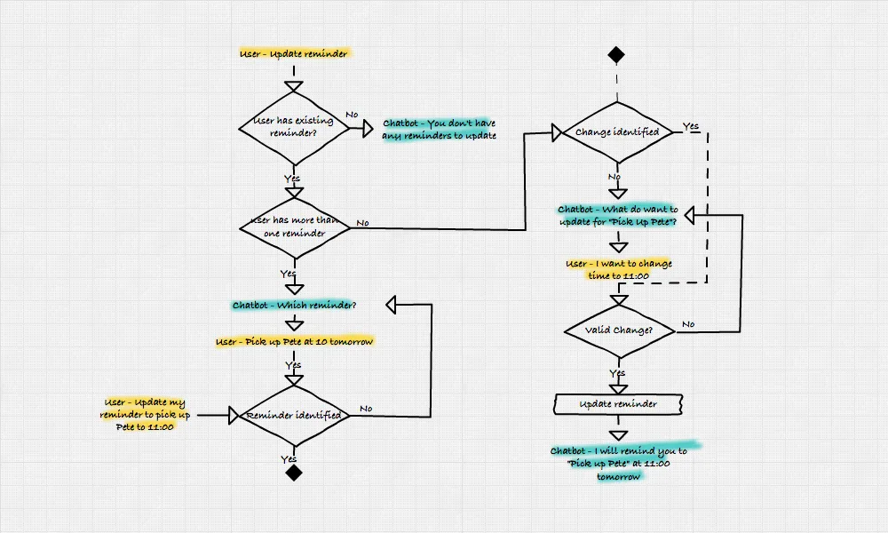

# 

**5.2 GUI of Working System**

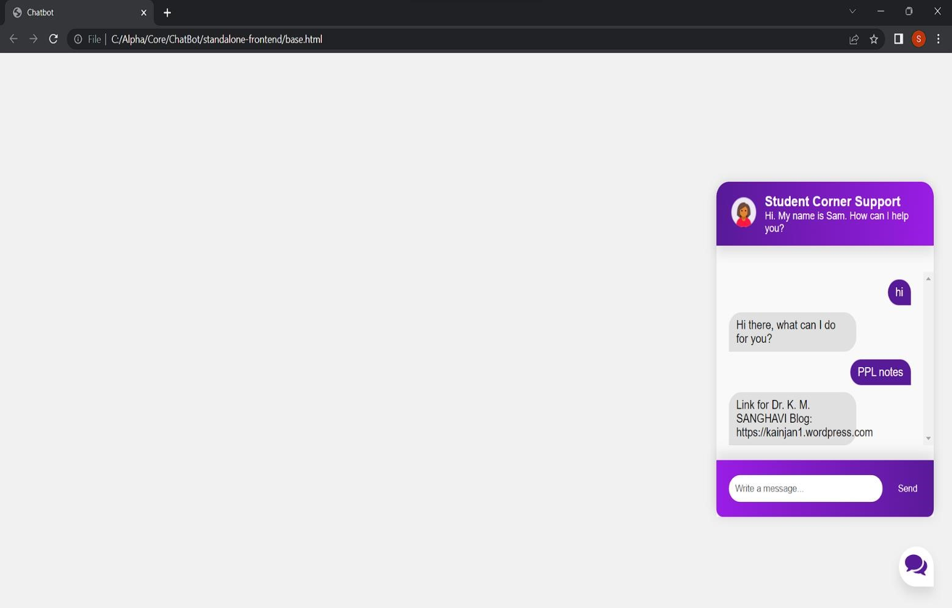

**GUI of Chatbot giving Correct Response**

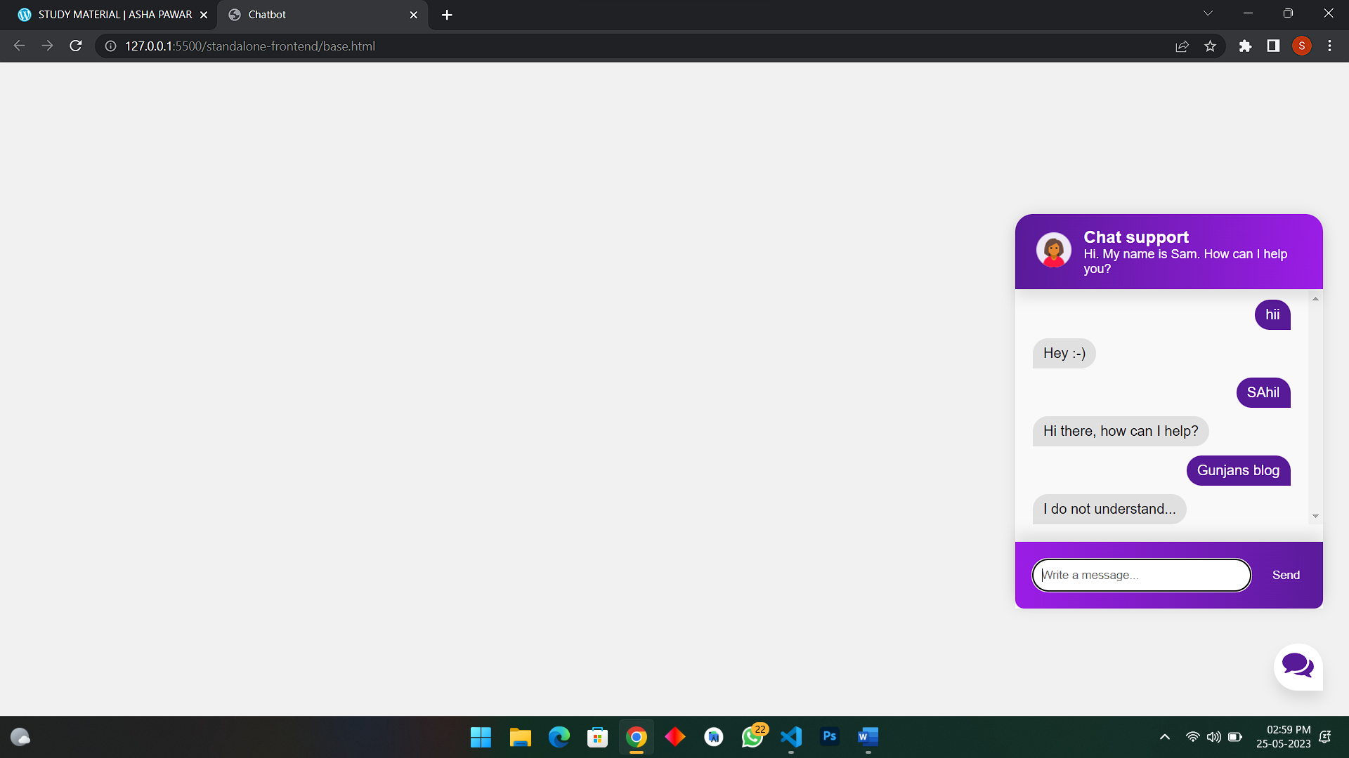

**GUI of Chatbot Not Understanding the given Query**

**Chapter 6**

**Conclusion and Future Scope**

In conclusion, chatbots have become increasingly popular in recent years due to their ability to provide fast, efficient, and cost-effective customer service and support. They can be used in a variety of industries and applications, including customer service, healthcare, e-commerce, and more.

Chatbots offer several advantages, including 24/7 availability, fast response times, cost effectiveness, personalized experiences, scalability, and improved customer service.

However, they also have limitations and potential drawbacks, such as limited conversational ability, dependence on technology, lack of empathy, and potential security risks. Therefore, businesses must carefully consider their use and implementation of chatbots to ensure that they provide a positive experience for users and achieve their intended goals.

Future Scope:

Integration with more platforms: The chatbot can be integrated with more platforms, such as social media, messaging apps, and voice assistants, to provide students with a seamless experience. This will enable students to access the chatbot from any device or platform of their choice, increasing its accessibility and convenience.

Personalized recommendations: The chatbot can be enhanced with machine learning algorithms to provide personalized recommendations to students. By analyzing a student's academic performance, interests, and goals, the chatbot can suggest relevant courses, extracurricular activities, and resources.

Enhanced security and privacy features: The chatbot can be enhanced with advanced security and privacy features, such as two-factor authentication and end-to-end encryption, to protect students' sensitive information.

Overall, the future scope of the Chatbot for Student project is vast, and the possibilities for its development and improvement are endless. By continuing to innovate and incorporate emerging technologies, the chatbot can become an essential tool for students, providing

them with personalized and efficient support throughout their academic journey

**Chapter7**

**References**

**[1]** Design and Development of a Chatbot-based Learning Environment for Computer Science Students" by Akingbola,[2021]

* YouTube https://www.youtube.com/watch?v=6GLFcm7dGiY

* GitHub https://github.com/Nada-Khater/3D-Avatar-Chatbot-UI

* Wikipedia

* Java point

* Chat GPT Basic concept

* Stack overflow

* GeeksforGeeks

* Research Paper

[https://www.researchgate.net/publication/361039365_Conversational_Agents_in_Education__A_Systematic_Literature_Review](https://www.researchgate.net/publication/361039365_Conversational_Agents_in_Education_-_A_Systematic_Literature_Review)